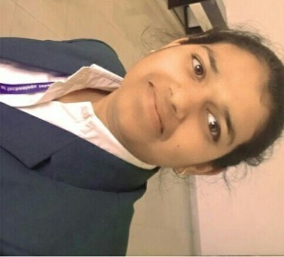 POORVI PATEL

*  +91 7974315502
*  patelpoorvi1974@gmil.com
*  Sihoda Bheraghat near railway station Jabalpur (M.P.)
* **C:\Users\acer\Downloads\birthday-cake.png** 14/11/2003­
* **C:\Users\acer\Downloads\hub.png** Computer Science and Engineering
* C:\Users\acer\Downloads\linkedin.png <https://www.linkedin.com/in/poorvi-patel-46230b270>
* https://github.com/poorvi0217

|  |
| --- |
| **Career Objective** |

To seek the challenging career in the corporate world, where my knowledge and skills will be enhanced and optimized so as to be the asset rather than cost

to the organization.

|  |
| --- |
| **Education** |

* **Bachelor of Technology, (CSE),** 2020 – 2024

Lakshmi Narain College of Technology current CGPA-8.30 Jabalpur

* **Class 12th,** 2020

Shiv Shakti International School P/S/M - 67% Jabalpur

* **Class 10th,** 2018

Shiv Shakti International School. - 51% Jabalpur

|  |
| --- |
| **Technical Skills** |

* Programming Language - HTML, CSS, Javascript, Basic(Java)
* Subjects Knowledge - DBMS, OOP’s, DSA

|  |
| --- |
| **Certificate** |

* I have obtained certifications in HTML, CSS, basic(Java) and Javascript .

|  |
| --- |
| **Project** |

* **Title :-** **E-COMMERCE WEBSITE: An online platform for sports**

**related stuff**.

* **Description:-** Creating an E-commerce internet utility is required for looking out and buying in each shop, after going through all the challenges and weaknesses of the offline buying device.These days, several e-commerce websites have been launched, such as Flipkart, Amazon, and Myntra, where people can quickly purchase their required things.

|  |
| --- |
| **Activities** |

* **Extra-Curricular Activities:-**Successfully completed skit, drama & more thinks in college event andachieved most energetic performance prize.

|  |
| --- |
| **Hobbies** |

* Painting
* Reading books

|  |
| --- |
| **Declaration** |

I hereby declare that all above informationis true to the best of my

knowledge and belief.

**Date:**____________ **(Poorvi Patel)**